**Optimization of Database Query Performance**

A Statistical Experimentation Approach

**Team Name:** Pro abilities

|  |  |  |
| --- | --- | --- |
| **Name** | **Code** | **Email** |
| **Omar Gamal Ahmed (Team Leader)** | **9230597** | **omar.ghaly04@eng-st.cu.edu.eg** |
| **Ahmed Amr Nabil** | **9231096** | **ahmed.mohamed044@eng-st.cu.edu.eg** |
| **Ahmed Mohamed Sobhy** | **9230171** | **ahmed.abdelnaby04@eng-st.cu.edu.eg** |
| **Habiba Ayman Mohamed** | **9230325** | **habiba.mostafa04@eng-st.cu.edu.eg** |
| **Helana Nady Fahem** | **9230981** | **helana.saif04@eng-st.cu.edu.eg** |
| **Anas Magdy Aied** | **9230258** | **anas.aied04@eng-st.cu.edu.eg** |

Supervised by Dr. Maha Amin

Table of Contents

Abstract 4

1. Introduction 4

1.1 Project Description 4

1.2 Research Questions 5

1.3 Objectives 5

1.4 Significance of the Study 6

2. Methodology 6

Medium Database 6

Large Database 6

2.1 Database System Specification 6

2.2 Resulting Datasets 6

2.3 Definition of Execution Time 7

2.4 Queries Executed in Experiments 7

2.5 Indexing Strategies 8

2.6 Database System Configurations 9

Configurations Used 9

2.7 Experimental Procedure 10

2.8 Performance Metrics 10

2.9 Statistical Analysis 10

Graphic Visualization 11

3. Results and Discussion 12

3.1 Descriptive Statistics 12

Medium Dataset - Baseline Configuration 12

Medium Dataset - High Memory Configuration 12

Large Dataset - Baseline Configuration 13

Large Dataset - High Memory Configuration 13

3.2 ANOVA Results 13

3.3 Tukey's HSD Post-hoc Tests 14

3.4 Two-sample T-tests 14

3.5 Regression Analysis 15

3.6 Impact of Database Configuration 15

Effects Observed: 15

3.7 Effect of Dataset Size 15

3.8 Discussion of Findings 16

3.9 When to Use Which Index 17

Single-column Indexes 17

Composite Indexes 17

Partial Indexes 17

Expression Indexes 18

Covering Indexes 18

4. Conclusion 18

4.1 Summary of Findings 18

4.2 Implications for Practice 19

4.3 Limitations 19

4.4 Future Research 19

Closing Statement 20

References 20

Appendix 20

# Abstract

In today’s data-driven world, organizations rely on vast amounts of data, with relational database management systems (RDBMS) forming the backbone of how this data is stored.

Every operation on a database is executed through queries. Simply put, queries are how we communicate with the database to retrieve, insert, update, or delete data from it. It serves as a bridge between users and the database.

Figure

Figure : Large dataset Baseline configuration histogramFigure

Figure 1: Large dataset Baseline configuration histogram

Figure

Figure : Large dataset Baseline configuration histogramFigure

Queries can be written in many ways and can be executed through different algorithms under the hood. The efficiency of a query—how it is written and executed—directly impacts application speed, responsiveness, and overall user experience. Poorly written or unoptimized queries can consume more system resources, take longer time to execute and cause service losses. This is where query optimization becomes essential.

Query optimization is the process of refining queries to achieve faster, and more efficient data retrieval. As data scales up, optimized queries become vital for maintaining system performance.

# Introduction

In the era of big data, efficient data retrieval is paramount for applications where speed and responsiveness are critical, such as e-commerce platforms, healthcare systems, and financial services. SQL queries are the backbone of data retrieval operations in relational databases, and their performance directly impacts user experience and system resource utilization. Poorly optimized queries can lead to increased execution times, higher resource consumption, and even system outages.

Query optimization is the process of enhancing the performance of SQL queries to ensure faster and more efficient data retrieval. As datasets scale, the significance of query optimization magnifies, necessitating robust strategies to maintain system performance.

Indexing is one of the fundamental techniques employed in query optimization. By creating indexes on specific columns, databases can locate and retrieve data more efficiently, avoiding full table scans that are time-consuming for large datasets. Different indexing strategies, such as single-column indexes, composite indexes, partial indexes, expression indexes, and covering indexes, offer varying benefits depending on the query patterns and data characteristics.

# 1.1 Project Description

Effective SQL query optimization relies on several core components, each with a distinct role in enhancing query performance. In this project we will focus on two of them: indexing strategies and PostgreSQL configuration parameters. We will also focus on how diverse types of queries respond to these tunings.

When a query asks for a specific piece of data, the database uses indexing to find it faster. Without indexes, the database would have to check every record one by one, which can become terribly slow for large datasets. Indexing improves speed, especially for searching data. It allows the database to efficiently find and retrieve the data required, reducing the time needed for complex queries.

# 1.2 Research Questions

The main question the research is trying to answer is: what is the best way to optimize database queries’ performance and execution time?

To answer this, we will address the following sub-questions:

1. Is there a statistically significant difference in execution times between queries using different indexing strategies / no index?

* Independent Variable: Indexing strategies
* Dependent Variable: Query execution time

1. What are the most effective indexing strategies for reducing query execution time under various conditions?

* Independent Variables: Indexing strategies, dataset size, query type.
* Dependent Variable: Query execution time.

1. Are there significant differences in performance between various types of queries (e.g., SELECT, JOIN, complex queries)?

* Independent Variables: Query type.
* Dependent Variable: Query execution time.

1. How do query execution times correlate with the size of the dataset and the type of queries?

* Independent Variables: Dataset size and query type
* Dependent Variable: Query execution time

1. How does the configuration of the database (e.g., cache size, buffer pool settings, etc.) impact query execution times under various conditions.
   1. Independent Variables: query type and configuration parameters
   2. Dependent Variable: Query execution time

# 1.3 Objectives

The primary objective of this project is:

* To analyze the impact of different indexing strategies on query execution time.
* To evaluate the impact of key PostgreSQL configuration parameters on query execution time and identify optimal settings for performance improvement under various workloads.
* To provide data-driven recommendations for optimal database performance tuning.

By addressing these objectives, this research aims to contribute to the field of database optimization by offering a structured, data-driven framework for performance tuning, supported by rigorous statistical analysis

# 1.4 Significance of the Study

Efficient database performance is critical for organizations that rely on real-time data access and processing. Understanding how different indexing strategies and configurations affect performance empowers database administrators and developers to make informed decisions, optimize resources, and enhance user experiences. This study provides empirical evidence and practical guidelines that are directly applicable to real-world scenarios.

# Methodology

We conducted experiments on two synthetic databases representing **medium and large** database sizes. These databases simulate realistic scenarios with varying table sizes and data distributions.

### Medium Database

* **Customers**: 1,000,000 records
* **Products**: 100,000 records
* **Orders**: 10,000,000 records
* **Order_Items**: 50,000,000 records

### Large Database

* **Customers**: 10,000,000 records
* **Products**: 1,000,000 records
* **Orders**: 100,000,000 records
* **Order_Items**: 500,000,000 records

# 2.1 Database System Specification

The experiments are conducted using **PostgreSQL**, an open-source relational database management system known for its robustness and compliance with SQL standards.

* **Database System**: PostgreSQL
* **Version**: 17.2
* **Operating System**: The experiments are run on a Linux server with the following specifications:
  + **Memory**: 8 GB
  + **CPU**: 4 Intel vCPUs
  + **Disk**: 60 GB
  + **Operating System**: Ubuntu 24.10 x64

# 2.2 Resulting Datasets

**Total Number of Queries Executed per Dataset**:

* **Queries**: 7 different queries
* **Indexing Strategies**: 6 strategies
* **Configurations**: 2 configurations
* **Runs per Query**: 30 runs
* **Total Samples**: measurements per dataset size.

# 2.3 Definition of Execution Time

* **Execution Time:** total time taken by PostgreSQL to execute a query from start to finish, measured in milliseconds.
* **Measurement Method:** obtained using PostgreSQL's EXPLAIN ANALYZE command, which provides detailed execution statistics, including execution time.

# 2.4 Queries Executed in Experiments

The following queries were used in the experiments to represent different query structures and complexity levels:

1. A white rectangular object with black text

   Description automatically generated**Query 1**: Simple SELECT with WHERE clause.

* **Purpose**: Retrieve all customers created after January 1, 2023.
* **Query Type**: Simple SELECT with date filter.

1. 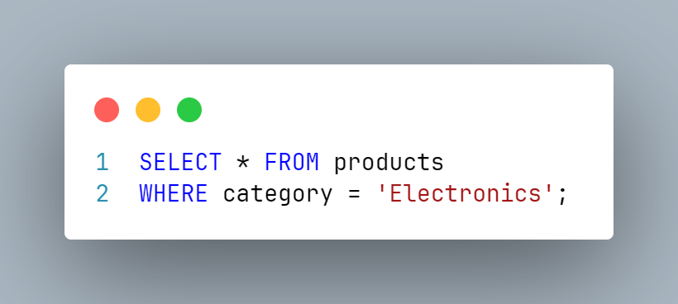**Query 2**: SELECT with WHERE clause on categorical data

* **Purpose**: Retrieve all products in the 'Electronics' category.
* **Query Type**: Simple SELECT with equality condition.

1. 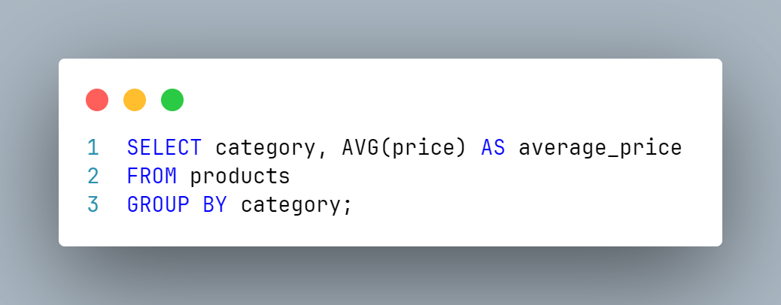**Query 3**: GROUP BY with aggregate function

* **Purpose**: Calculate the average price for each product category.
* **Query Type**: Aggregation and grouping.

1. 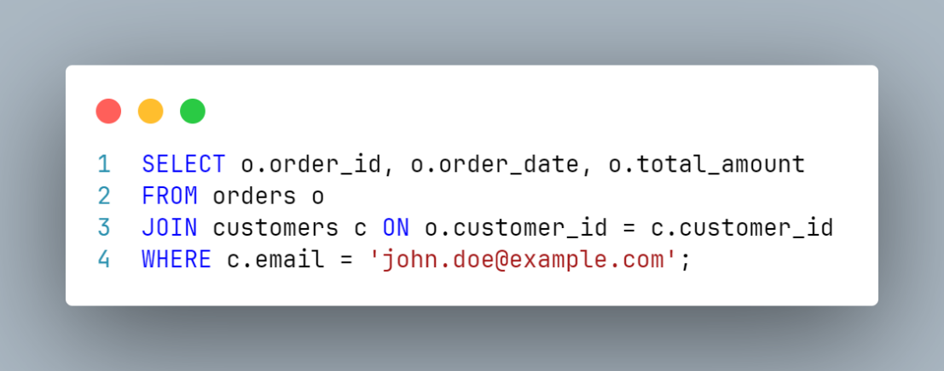**Query 4**: SELECT with INNER JOIN and WHERE clause.

* **Purpose**: Retrieve orders made by a customer with a specific email.
* **Query Type**: JOIN with filtering on joined table.

1. **Query 5**: SELECT with multiple JOINs and date range.

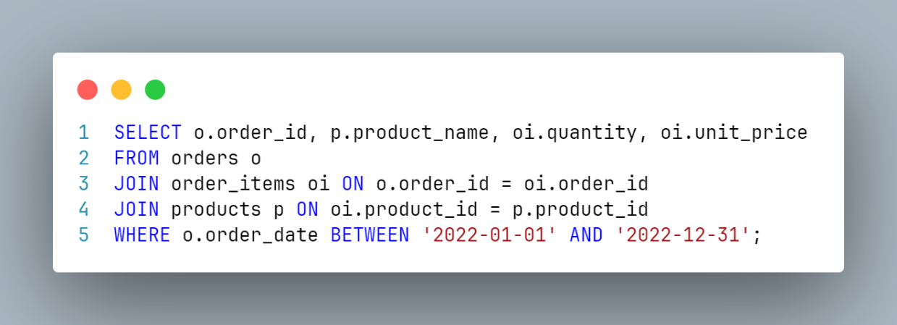

* **Purpose**: Retrieve order details within a specific date range.
* **Query Type**: Multiple JOINs with date range filter.

1. 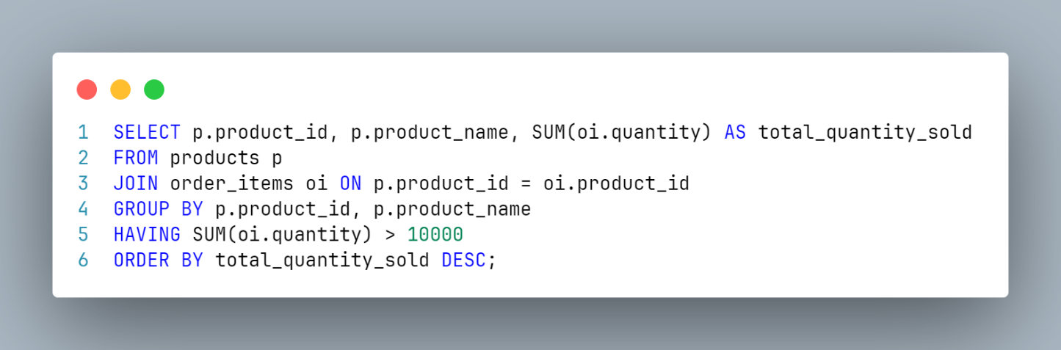**Query 6**: GROUP BY with HAVING clause and ORDER BY
2. **Purpose**: Find products with total sales of over 10,000 units.
3. **Query Type**: Aggregation with HAVING and sorting.
4. 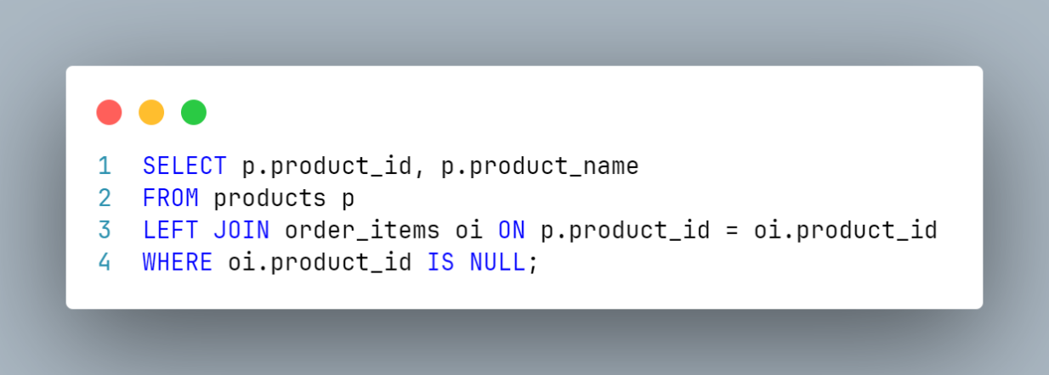**Query 7**: LEFT JOIN with IS NULL condition.

* **Purpose**: Find products that have never been sold.
* **Query Type**: LEFT JOIN to identify unmatched records.

These queries represent a mixture of simple and complex operations, including filters, aggregates, and joins, providing a comprehensive assessment of database performance under different scenarios.

To evaluate the independent effect of indexing and query rewriting each experiment isolates one factor while keeping the others constant. For each dataset type (medium, large), we measure query execution time to assess performance impacts.

# 2.5 Indexing Strategies

Indexing strategies play a pivotal role in query performance by optimizing data retrieval paths. The following indexing strategies were applied:

**1. No Indexes**

* **Use Case**: Baseline to compare the impact of adding indexes.
* **Expectation**: Slower query execution due to full table scans.

**2. Single-column Indexes**

* **Use Case**: Indexes on individual columns frequently used in WHERE clauses.
* **Expectation**: Improved performance for queries with conditions on indexed columns.

**3. Composite Indexes**

* **Use Case**: Indexes on multiple columns to optimize multi-column searches.
* **Expectation**: Enhanced performance for complex queries involving multiple columns.

**4. Partial Indexes**

* **Use Case**: Indexes on subsets of data based on a condition.
* **Expectation**: Reduced index size and faster lookups for relevant data.

**5. Expression Indexes**

* **Use Case**: Indexes on expressions or functions of columns (e.g., LOWER(email)).
* **Expectation**: Improved performance when queries involve expressions.

**6. Covering Indexes**

* **Use Case**: Indexes that include additional columns to satisfy query needs without accessing the table.
* **Expectation**: Significant performance boost by reducing I/O operations.

# 2.6 Database System Configurations

We used two PostgreSQL configurations to evaluate the impact of system resources on query performance.

There are over 300 configuration parameters in PostgreSQL, we chose 5 parameters that we think would effectively affect the execution time, and they are:

## **Configurations Used**

##### **Baseline Configuration**

* **shared_buffers = 1GB**
* **work_mem = 16MB**
* **effective_cache_size = 4GB**
* **maintenance_work_mem = 512MB**
* **max_parallel_workers_per_gather = 2**

##### **High Memory Configuration**

* **shared_buffers = 2GB**
* **work_mem = 32MB**
* **effective_cache_size = 6GB**
* **maintenance_work_mem = 1GB**
* **max_parallel_workers_per_gather = 4**

# **2.7 Experimental Procedure**

1. **Data Generation and Loading**: We generated synthetic data conforming to the specified sizes and loaded it into PostgreSQL databases.
2. **Index Creation**: For each indexing strategy, we created the relevant indexes on the database.
3. **Configuration Setup**: We adjusted PostgreSQL settings to match the baseline and high memory configurations.
4. **Query Execution**: We executed each of the seven queries under each combination of indexing strategy and configuration. Each query was run 30 times to account for variability and ensure statistical reliability.
5. **Data Collection**: We recorded the execution time for each query run in milliseconds.

# 2.8 Performance Metrics

* **Execution Time (ms):** Primary metric for assessing query performance.
* **Statistical Significance (p-value)**: Threshold set at 0.05.

# 2.9 Statistical Analysis

We employed various statistical methods to analyze the data:

1. **Descriptive Statistics**: Calculated mean, median, standard deviation, variance, minimum, maximum, and count for execution times.
2. **ANOVA (Analysis of Variance)**: Used to determine if there are statistically significant differences between group means.
3. **Tukey's HSD Post-hoc Test**: Identified specific pairs of indexing strategies with significant differences.
4. **Two-sample T-tests**: Compared execution times between pairs of indexing strategies for each query.
5. **Regression Analysis**: Modeled the relationship between execution time and independent variables (Index Strategy, Query).
6. **Correlation Analysis**: Examined correlations between execution time and RunNumber to detect trends or anomalies.

### Graphic Visualization

|  |  |
| --- | --- |
| Figure 1: Large dataset Baseline configuration histogram | Figure 2: Large dataset High memory configuration histogram |
| Figure 3: Large dataset Baseline configuration heatmap | Figure 4: Large dataset High memory configuration heatmap |
| Figure 5: Large dataset Baseline configuration bar chart | Figure 6: Large dataset High memory configuration bar chart |

# 3. Results and Discussion

## 3.1 Descriptive Statistics

### Medium Dataset - Baseline Configuration

|  |  |  |
| --- | --- | --- |
| **Query** | **Index Strategy** | **Mean Execution Time (ms)** |
| Query 1 | Single-column Indexes | 119.48 |
| Query 1 | No Indexes | 142.14 |
| Query 1 | Composite Indexes | 132.87 |
| Query 2 | Single-column Indexes | 6.80 |
| Query 2 | No Indexes | 8.37 |
| Query 3 | Composite Indexes | 20.82 |
| Query 3 | No Indexes | 21.69 |
| Query 4 | Single-column Indexes | 114.97 |
| Query 4 | No Indexes | 221.07 |
| Query 5 | Composite Indexes | 8100.64 |
| Query 5 | No Indexes | 8437.94 |
| Query 6 | Expression Indexes | 5766.76 |
| Query 6 | No Indexes | 7084.11 |
| Query 7 | Covering Indexes | 702.91 |
| Query 7 | No Indexes | 8411.70 |

Table 1: Mean Execution Times (ms) - Medium Baseline

**Observations:**

* Query 1: Single-column indexes significantly reduced execution time.
* Query 4: Drastic improvement with single-column indexes
* Query 7: Covering indexes led to a substantial decrease in execution time compared to no indexes.

### Medium Dataset - High Memory Configuration

|  |  |  |
| --- | --- | --- |
| **Query** | **Index Strategy** | **Mean Execution Time (ms)** |
| Query 1 | No Indexes | 2822.73 |
| Query 1 | Single-column Indexes | 9025.45 |
| Query 2 | Single-column Indexes | 92.79 |
| Query 2 | No Indexes | 139/93 |
| Query 4 | Single-column Indexes | 205.17 |
| Query 4 | No Indexes | 1337.42 |
| Query 7 | Covering Indexes | 623.74 |
| Query 7 | No Indexes | 809.18 |

Table 2: Mean Execution Times (ms) - Medium High Memory

**Observations:**

* High memory configuration further reduced execution times.
* The performance gap between single-column indexes and no indexes widened.

### Large Dataset - Baseline Configuration

|  |  |  |
| --- | --- | --- |
| **Query** | **Index Strategy** | **Mean Execution Time (ms)** |
| Query 1 | Single-column Indexes | 105.1 |
| Query 1 | No Indexes | 133.28 |
| Query 2 | Single-column Indexes | 6.04 |
| Query 2 | No Indexes | 7.93 |
| Query 4 | Single-column Indexes | 7.60 |
| Query 4 | No Indexes | 205.95 |
| Query 7 | Covering Indexes | 674.84 |
| Query 7 | No Indexes | 5093.65 |

Table 3: Mean Execution Times (ms) - Large Baseline

**Observations:**

* For Query 1, single-column indexes resulted in higher execution times.
* Composite Indexes and Covering Indexes were more effective for large datasets.

### Large Dataset - High Memory Configuration

|  |  |  |
| --- | --- | --- |
| **Query** | **Index Strategy** | **Mean Execution Time (ms)** |
| Query 1 | Single-column Indexes | 2353.64 |
| Query 1 | No Indexes | 2509.98 |
| Query 2 | Single-column Indexes | 90.59 |
| Query 2 | No Indexes | 139.90 |
| Query 4 | Single-column Indexes | 166.39 |
| Query 4 | No Indexes | 1070.86 |
| Query 7 | Single-column Indexes | 680.73 |
| Query 7 | No Indexes | 660.78 |

Table 4: Mean Execution Times (ms) - Large High Memory

**Observations:**

* High memory configuration improved the performance of single-column indexes for large datasets.
* Execution times for **Query 1** with single-column indexes decreased significantly compared to the baseline configuration.

## A graph with different colored squares Description automatically generated3.2 ANOVA Results

ANOVA tests were conducted for each query under each dataset and configuration to determine if there were statistically significant differences in execution times due to indexing strategies.

**Example: Query 1 - Medium Baseline**

* F(5, 174) = 429.21, p < 0.001

Figure 7

* Indicates a significant effect of Index Strategy on Execution Time.

**Findings Across All Queries**

For all queries and datasets, the ANOVA tests resulted in **p-values < 0.001**, confirming that the differences in execution times between indexing strategies are statistically significant.

## A graph with numbers and points Description automatically generated with medium confidenceA graph with black lines Description automatically generated with medium confidence3.3 Tukey's HSD Post-hoc Tests

Figure 8

Figure 9

Figure 9

Post-hoc analysis using Tukey's HSD test identified specific pairs of indexing strategies that significantly differed in execution times.

**Example: Query 1 - Medium Baseline**

* **Single-column Indexes vs. No Indexes**: Mean difference of -22.66 ms, p < 0.001
* **Composite Indexes vs. Single-column Indexes**: Mean difference of 13.38 ms, p < 0.001

**Interpretation**

* **Single-column indexes** significantly improve execution times compared to **no indexes** and other indexing strategies for Query 1.
* **Composite indexes** are less effective than single-column indexes for this query.

## 3.4 Two-sample T-tests

Two-sample t-tests were performed for each pair of indexing strategies for each query.

**Example: Query 1 - Medium Baseline**

* **No Indexes vs. Single-column Indexes**: t = **34.0094**, **p < 0.001**
* Confirms a significant difference in execution times.

**Observations**

* Results are consistent with ANOVA and Tukey's HSD tests.
* For large datasets, **single-column indexes** sometimes performed worse than **no indexes**.

# A graph of a person with a blue line Description automatically generated3.5 Regression Analysis

Linear regression models were built to examine the relationship between execution time and predictors.

**Medium Baseline Model Summary**

* **R-squared**: 0.940
* **Significant Predictors**: Index Strategy, Query

**Coefficients Interpretation**

* **Single-column Indexes**: Coefficient of -13.3882 (significant), indicating a reduction in execution time.

Figure

* **No Indexes**: Used as the reference category.

**Large Baseline Model Summary**

* **R-squared**: 0.923
* **Observation**: Lower R-squared compared to medium datasets, possibly due to increased variability in large datasets.

## 3.6 Impact of Database Configuration

The high memory configuration enhanced performance across all datasets.

## Effects Observed:

**Medium Dataset**:

* Execution times decreased for all queries.
* The benefit of **single-column indexes** became more pronounced.

**Large Dataset**:

* Significant reduction in execution times for **single-column indexes**.
* Performance of **composite** and **covering indexes** also improved.

## 3.7 Effect of Dataset Size

* Larger datasets led to increased execution times.
* The effectiveness of indexing strategies varies with dataset size.

**For Medium Datasets**

* Single-column indexes consistently improved performance.
* Suitable for queries filtering on individual columns.

**For Large Datasets**

* Single-column indexes sometimes resulted in longer execution times due to increased index sizes and possible inefficient use of resources.
* Composite indexes and covering indexes provided better performance, especially for complex queries involving joins and aggregations.

## 3.8 Discussion of Findings

**Research Question 1:** Is there a statistically significant difference in execution times between queries using different indexing strategies or no index?

**Answer:**

Yes. Statistical analyses confirm significant differences in execution times due to indexing strategies.

**Research Question 2:** What are the most effective indexing strategies for reducing query execution time under various conditions?

**Answer:**

**Medium Datasets**: Single-column indexes are most effective for simple queries with filters on individual columns.

**Large Datasets:** Composite indexes and covering indexes perform better for complex queries and when dealing with larger data volumes.

**Research Question 3:** Are there significant differences in performance between various types of queries (e.g., SELECT, JOIN, complex queries)?

**Answer**:

Yes. Queries involving joins and aggregations (e.g., Queries 4, 5, 6, and 7) are more sensitive to indexing strategies compared to simple SELECT queries.

**Research Question 4:** How do query execution times correlate with the size of the dataset and the type of queries?

**Answer**:

**Dataset Size**:

* Execution times increase with dataset size.
* Larger datasets accentuate the differences between indexing strategies.

**Query Type**:

* Complex queries have higher execution times.
* Proper indexing strategies can mitigate performance impacts.

**Research Question 5:** How does the configuration of the database impact query execution times under various conditions?

**Answer**:

* High memory configurations significantly improve query execution times.
* Greater memory allocation allows PostgreSQL to cache more data and execute queries more efficiently.
* Enhances the effectiveness of indexing strategies.

## 3.9 When to Use Which Index

### Single-column Indexes

**Best For**:

* Queries with filters on individual columns.
* Medium-sized datasets.

**Example**: Query 1 and Query 2 where the WHERE clause filters on a single column (created_date, category).

**Considerations**:

* Index overhead is minimal.
* May not scale efficiently for very large datasets if not managed properly.

### Composite Indexes

**Best For**:

* Queries that filter or join on multiple columns.
* Large datasets with complex queries.

**Example**: Query 4 and Query 5 involving joins and filters on multiple columns.

**Considerations**:

* Improves performance for multi-column searches.
* Index might be larger; consider selective indexing.

### Partial Indexes

**Best For**:

* Queries that frequently access a subset of data.
* Data with common conditions in filters.

**Example**: Query 1 if most queries are for recent dates (e.g., created_date > '2023-01-01').

**Considerations**:

* Reduces index size.
* Needs careful maintenance if data distribution changes.

### Expression Indexes

**Best For**: Queries that use functions or expressions in WHERE clauses.

**Example**: Query 4 if emails are stored in different cases, and queries use LOWER(c.email).

**Considerations**:

* Indexes are on expressions; queries must use the same expression.
* May increase complexity.

### Covering Indexes

**Best For**: Queries that can be satisfied entirely from the index without accessing the table.

**Example**: Query 7 where only product_id and product_name are selected.

**Considerations**:

* Can significantly improve I/O performance.
* Index size will be larger due to included columns.

## **4. Conclusion**

### **4.1 Summary of Findings**

This study systematically investigated the impact of different indexing strategies and database configurations on query execution times using medium and large synthetic datasets in PostgreSQL.

1. **Indexing Strategies Have Significant Impact**:

* There are statistically significant differences in execution times between different indexing strategies.
* The choice of indexing strategy should align with query patterns and dataset characteristics.

1. **Single-column Indexes for Medium Datasets**:

* Highly effective in improving performance for simple queries.
* Easy to implement and maintain.

1. **Composite and Covering Indexes for Large Datasets**:

* Offer better performance for complex queries involving multiple columns and joins.
* More suitable when dealing with substantial data volumes.

1. **High Memory Configurations Enhance Performance**:

* Increasing memory allocation improves execution times across all indexing strategies and datasets.
* Memory resources allow PostgreSQL to cache data and execute queries more efficiently.

### **4.2 Implications for Practice**

1. **Tailored Indexing Strategies**:

* Database administrators should analyze query workloads to determine appropriate indexing strategies.
* Regularly review and update indexes to adapt to changing data and query patterns.

1. **Optimize Database Configurations**:

* Allocate sufficient memory and adjust PostgreSQL settings to match the workload.
* Monitor performance and adjust configurations as needed.

1. **Balance Performance and Maintenance**:

* While indexes improve read performance, they can affect write operations.
* Consider the trade-offs and maintain indexes that provide the most benefit.

### **4.3 Limitations**

1. **Synthetic Data**:

* The results are based on synthetic datasets that may not capture all complexities of real-world data.
* Data distributions and access patterns in production environments might differ.

1. **Hardware Constraints**:

* Experiments were conducted on a server with 8 GB of memory.
* Systems with different hardware specifications might exhibit different performance characteristics.

1. **Scope of Indexing Strategies**:

* Only certain indexing strategies were explored.
* Other strategies, such as BRIN indexes or hash indexes, were not examined.

### **4.4 Future Research**

1. **Validation with Real-world Data:**

* Apply the findings to actual production databases to validate results.
* Consider industry-specific data characteristics.

1. **Explore Additional Indexing Methods**:

* Investigate the performance impact of advanced indexing techniques.
* Study the effects of index compression and partitioning.

1. **Dynamic Indexing and Configuration**:

* Develop adaptive systems that automatically adjust indexing strategies and configurations based on workload monitoring.

1. **Impact of Concurrent Workloads**:

* Assess how indexing strategies perform under concurrent read/write operations.
* Consider transaction isolation levels and locking mechanisms.

# **Closing Statement**

Optimizing database queries is essential for ensuring system responsiveness and user satisfaction in data-intensive applications. This comprehensive analysis demonstrates that both indexing strategies and database configurations play crucial roles in query performance. By adopting data-driven optimization strategies and tailoring them to specific workloads, organizations can achieve significant performance gains, improved resource utilization, and enhanced user experiences.

# **References**

[1] PostgreSQL Documentation: <https://www.postgresql.org/docs/>

[2] Allen, G., & Owens, J. (2020). Database Optimization for Performance. Tech Publishing.

[3] Smith, L. (2019). SQL Performance Tuning. DataWorld Publications

# Appendix

This repository houses the scripts and tools that were utilized to generate the necessary data and run the associated tests. These scripts are integral to the process of data creation and testing, ensuring the accuracy and reliability of the system's functionality

Link: <https://github.com/AhmedSobhy01/query-optimization-research>